
ENGREG HIGH SCHOOL
24, Bankole Street, Pedro, Shomolu, Lagos
SS 3 COMPUTER STUDIES SCHEME OF WORK
2024/2025 SESSION

FIRST TERM
WEEKS | TOPIC | SUB-TOPIC
ONE | Networking | Definition, Uses, Types, Network Topology, Network devices, Advantages and Disadvantages
TWO | Cables and Connectors | Network and Computer cables and connectors, Power and Data Cables, Connectors
THREE | Introduction to world wide web | Definition, History, Basic terms, Protocols, Uses and benefits. Software for web development
FOUR | Presentation Package | Definition, Examples, Features.
FIVE | Database | Definition, Examples, Basic Terms, Forms, Computer database format.
SIX | High Level Language | Definition, Examples, Advantages of HLL over ML and LLL
SEVEN | Security and Ethics | Definition, Sources, Preventive Measures, Legal issues
EIGHT | Computer Graphics | Definition, Types, Examples, Features, Simple Designs
NINE | Data Representation | Definition, Description of data representation
TEN | Number Bases | Conversion in Number Systems, Basic Arithmetic in Number Bases
ELEVEN | Revision
TWELVE | Examination
THIRTEEN

ENGREG HIGH SCHOOL
24, Bankole Street, Pedro, Shomolu, Lagos
WEEK: 1 FIRST TERM SESSION: 2024/2025
SUBJECT: COMPUTER STUDIES |  | TOPIC: NETWORKING
CLASS: SS 3 | DATE: 9th – 13th September, 2024 | REFERENCE BOOKS: New Computer Studies for SS 3 by J.O.E Otuka et al Pages 1-9  Online with computers for SS 3 by Adedapo F. O. et al 1 - 15
LEARNING PURPOSE:  To provide foundational knowledge about how networks function, their various applications, and the devices that make them work. |  |  |  | LESSON PERIOD: 1  DURATION: 40 MINS
LEARNING OBJECTIVE: By the end of the lesson, students will be able to:  - Define Networking  - Identify the types of Networking.  - State uses of Networking  - Explain the advantages and Disadvantages of Networking. |  |  |  | KEYWORDS:  Networking, Devices, Resources, Modem, Router.
PREVIOUS LEARNING: The students are familiar with how files and resources are shared. |  | INSTRUCTIONAL MATERIALS:  Interactive board, computer system, Internet
LEARNING ACTIVITIES IN STEPS:  Step 1: The teacher marks assignment and makes correction.  Step 2: The teacher asks questions on previous knowledge  Step 3: The teacher modifies students’ response and introduces the new topic  Step 4: Students would be taken through the derailed explanation of the lesson content  Step 5: Students ask questions on the content of the lesson  Step 6: Students would be evaluated based on behavioural objectives  Step 7: Students Assignments are given and notes and marked |  |  | LEARNING TIME FOR EACH STEP:  Step 1: 3mins  Step 2: 2mins  Step 3: 3mins  Step 4: 20mins  Step 5: 2mins  Step 6: 7mins  Step 7: 3mins
LEARNING SKILLS:  Critical thinking, creative thinking, communicating and leadership development |  | ACTIVITY  Define networking and give two uses.
EVALUATIVE QUESTIONS:  - Define Networking  - Identify four types of Networking.  - State three uses of Networking  - Explain two advantages and Disadvantages of Networking. |  | ASSIGNMENT  Identify the primary purpose of a computer network and its role in resource sharing.
NETWORKING

Networking is the practice of connecting computers and devices to share resources like data, applications, and internet access. This connectivity enables communication and collaboration over local or global distances. A computer network, or simply a network, is a group of interconnected devices linked by communication channels to facilitate resource sharing.
USES OF NETWORKING
- File Sharing: Sharing files and data between computers.
- Resource Sharing: Sharing resources like printers and internet connections.
- Communication: Enabling communication via email, instant messaging, and video conferencing.
- Data Backup: Centralized data storage for backup and recovery.
- Remote Access: Accessing a computer or network from a remote location.
TYPES OF NETWORKING
- Local Area Network (LAN): Connects devices within a small geographic area like a building or campus.
- Wide Area Network (WAN): Covers broad areas, such as cities or countries, often connecting multiple LANs.
- Metropolitan Area Network (MAN): Spans a city or large campus, linking multiple LANs within a metropolitan area.
- Personal Area Network (PAN): Connects personal devices over short distances, such as Bluetooth.
- Campus Area Network (CAN): Connects multiple buildings within a campus, extending LANs across a larger area.
- Home Area Network (HAN): Connects devices within a home, such as computers and smart devices.
- Global Area Network (GAN): Links multiple WANs and LANs globally for worldwide connectivity.
NETWORK DEVICES
Network devices, also known as nodes, are essential components in a network that facilitate connection and communication. The most common network devices include routers, switches, hubs, modems, and network interface cards. Each of these devices plays a specific role in ensuring the smooth operation of a network.
- Router: Directs data between different networks.
- Switch: Connects devices within a network and directs data to specific destinations.
- Hub: Broadcasts data to all devices in a network segment.
- Modem: Converts digital data to analog signals for internet access.
- NIC (Network Interface Card): Enables a computer to connect to a network.
- Bridge: Connects similar networks to function as one.
- Access Point: Provides wireless connectivity to a wired network.
- Firewall: Protects the network by controlling traffic based on security rules.
ADVANTAGES OF NETWORKING
- Resource Sharing: Reduces costs by sharing resources.
- Improved Communication: Facilitates fast communication between users.
- Centralized Management: Simplifies data and resource management.
- Enhanced Connectivity: Promotes global collaboration.
- Data Sharing: Enables simultaneous access to shared data and applications.
DISADVANTAGES OF NETWORKING
- Security Risks: Vulnerable to hacking and data breaches.
- Complexity: Requires technical expertise to set up and maintain.
- Cost: Can be expensive, especially for large networks.
- Reliability: Dependent on the performance of network devices, with potential for disruptions.

ENGREG HIGH SCHOOL
24, Bankole Street, Pedro, Shomolu, Lagos
WEEK: 1 FIRST TERM SESSION: 2024/2025
SUBJECT: COMPUTER STUDIES |  | TOPIC: NETWORKING
CLASS: SS 3 | DATE: 9th – 13th September, 2024 | REFERENCE BOOKS: New Computer Studies for SS 3 by J.O.E Otuka et al Pages 1-9  Online with computers for SS 3 by Adedapo F. O. et al 1 - 15
LEARNING PURPOSE:  To provide students with a foundational understanding of network topologies, including their structures, advantages, and disadvantages. |  |  |  | LESSON PERIOD: 2  DURATION: 40 MINS
LEARNING OBJECTIVE: By the end of the lesson, students will be able to:  - Define Network Topology.  - Identify and Describe Basic Topologies.  - State the Advantages and Disadvantages of each topology. |  |  |  | KEYWORDS:  Networking, Devices, Resources, Modem, Router.
PREVIOUS LEARNING: The students are familiar with the definition of Networking, its uses and types. |  | INSTRUCTIONAL MATERIALS:  Interactive board, computer system, Internet
LEARNING ACTIVITIES IN STEPS:  Step 1: The teacher marks assignment and makes correction.  Step 2: The teacher asks questions on previous knowledge  Step 3: The teacher modifies students’ response and introduces the new topic  Step 4: Students would be taken through the derailed explanation of the lesson content  Step 5: Students ask questions on the content of the lesson  Step 6: Students would be evaluated based on behavioural objectives  Step 7: Students Assignments are given and notes and marked |  |  | LEARNING TIME FOR EACH STEP:  Step 1: 3mins  Step 2: 2mins  Step 3: 3mins  Step 4: 20mins  Step 5: 2mins  Step 6: 7mins  Step 7: 3mins
LEARNING SKILLS:  Critical thinking, creative thinking, communicating and leadership development |  | ACTIVITY  Discuss two benefits of each topology.
EVALUATIVE QUESTIONS:  - Define Network Topology.  - Identify and Describe Basic Topologies.  - State the Advantages and Disadvantages of each topology. |  | ASSIGNMENT  Identify how combining multiple topologies can create a more adaptable network.

NETWORK TOPOLOGY
In computer networking, topology refers to the arrangement of connected devices within a network. Network topologies are categorized into several basic types:

- Bus Topology: In a bus topology, all devices are connected to a single central cable, known as the backbone. This backbone acts as a shared communication medium. Example: Ethernet.

Advantages
- Easy to connect additional devices or peripherals.
- Requires less cable than star topology.
Disadvantages
- The entire network shuts down if there is a break in the main cable.
- Troubleshooting network failures can be challenging.
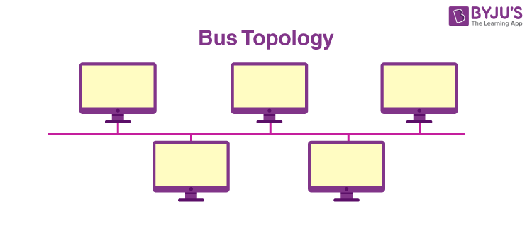

- Star Topology: In a star topology, all devices are connected to a central hub, switch, or router, forming a star-like structure. Example ARCNET.

Advantages
- Easy to install and wire.
- Faults are easy to detect and isolate.
Disadvantages
- Requires more cable length than a bus topology.
- More expensive due to the cost of hubs and additional cabling.
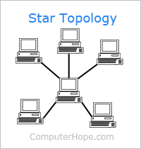

- Ring Topology: In a ring topology, each device is connected to two other devices, forming a circular or ring-like structure. Example: IBM Token Ring.

Advantage
Simple data flow with predictable performance.
Disadvantage
A single failure can impact the entire network.
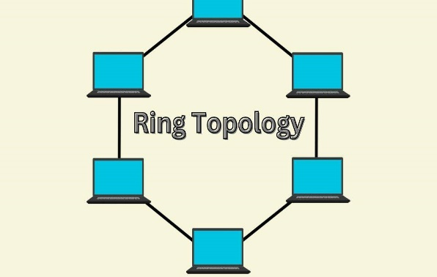

- Mesh Topology: Devices are interconnected with multiple paths for redundancy and reliability.

Advantages
- Multiple paths for data ensure high reliability; failure of one device or connection doesn’t affect the network.
- Adding new devices is straightforward without disrupting existing connections.
Disadvantages
- High cost due to extensive cabling and hardware.
- Troubleshooting is challenging because of the multiple data pathways.
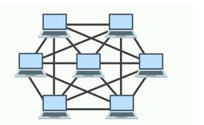

- Tree Topology: A hierarchical structure with a central root node, from which branches of connected nodes extend, resembling a tree. This topology combines characteristics of both star and bus topologies.
Advantages
- Adding new devices is simple and doesn't impact network performance.
- Centralized management allows for easier troubleshooting.
Disadvantages
- Failure of the root or main branch node can disrupt communication for entire segments.
- More complex to configure and maintain compared to simpler topologies.

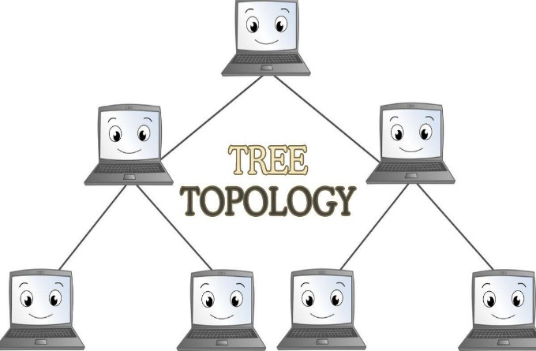

- Hybrid Topology: A hybrid topology in networking refers to a network structure that combines two or more different types of topologies, such as star, ring, bus, or mesh, to form a complex and more adaptable network design.

Advantages
- Leverages the strengths of multiple topologies for a customized and resilient network.
- Provides redundancy and fault tolerance, keeping the network operational even if one part fails.
Disadvantages
- Increases complexity, requiring advanced knowledge for setup and maintenance.
- Troubleshooting can be challenging due to the diverse and complex topology mix.